Name: Jorune Simpkins
Lab: 1C_bonus_F
Document Topic: Student Deliverables
Date: 2/1/2026

A) WAF Queries (CloudWatch Logs Insights)
A1) “What’s happening right now?” (Top actions: ALLOW/BLOCK)
fields @timestamp, action
| stats count() as hits by action
| sort hits desc

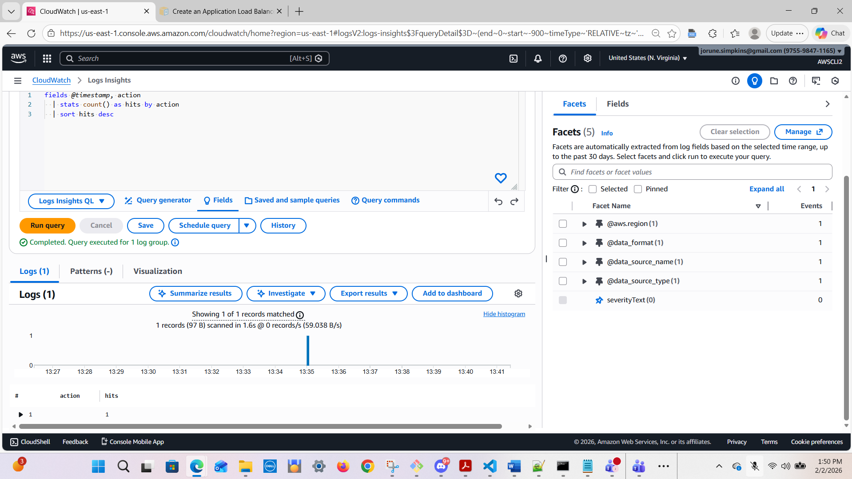

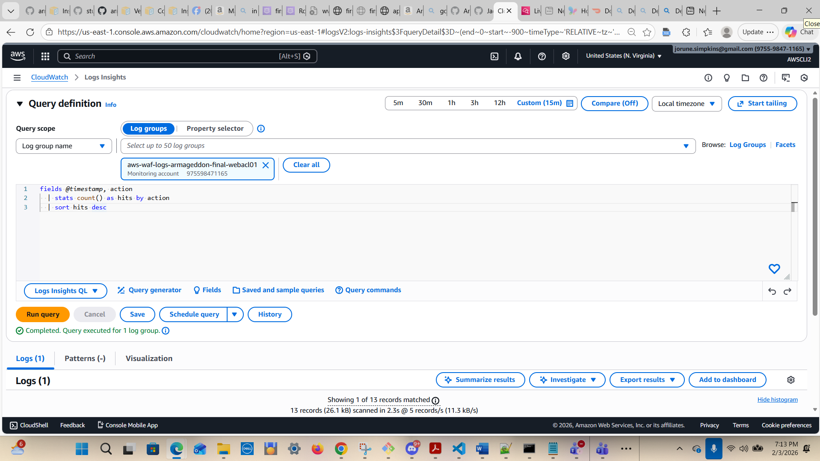

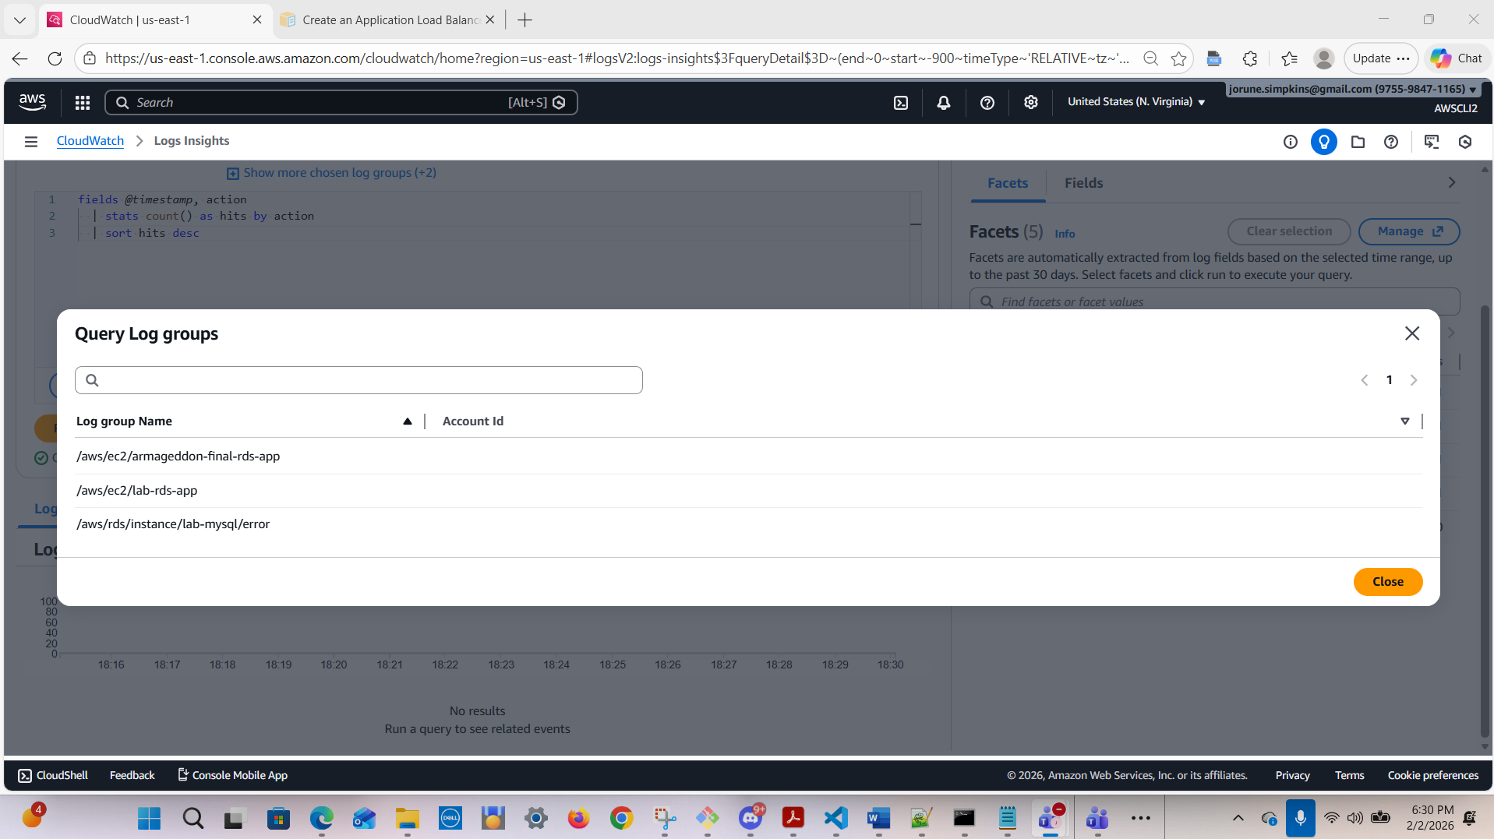

Note: Results after running

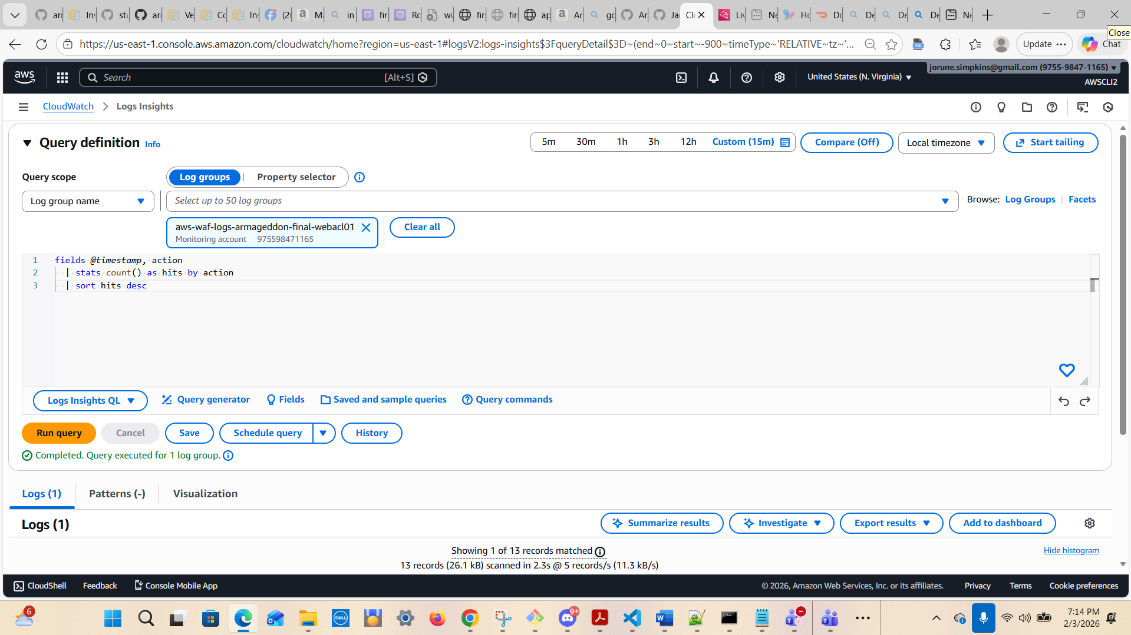

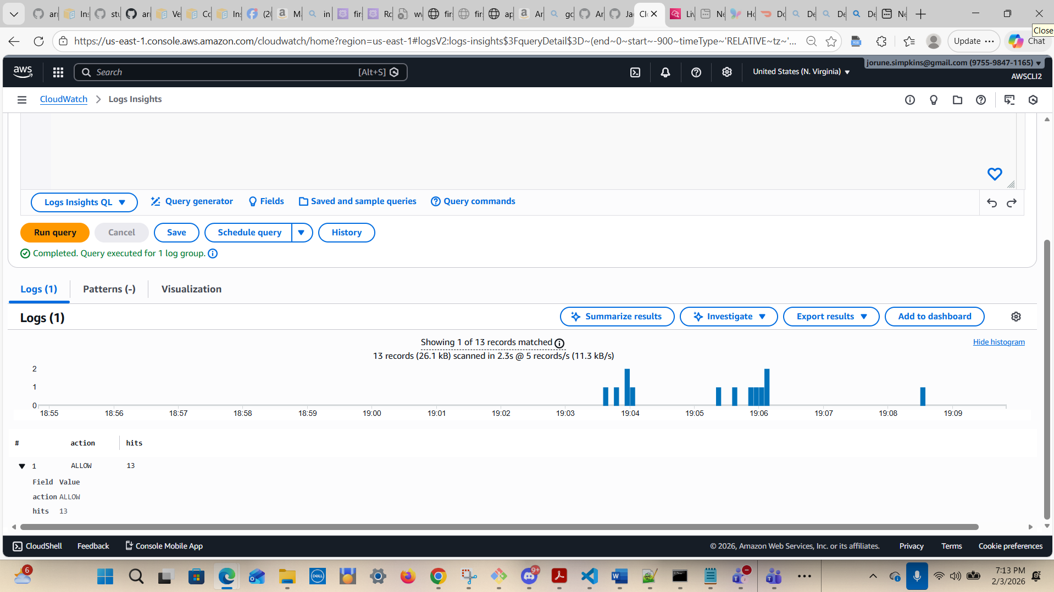
After running the error command: app.firstpointand.click/error
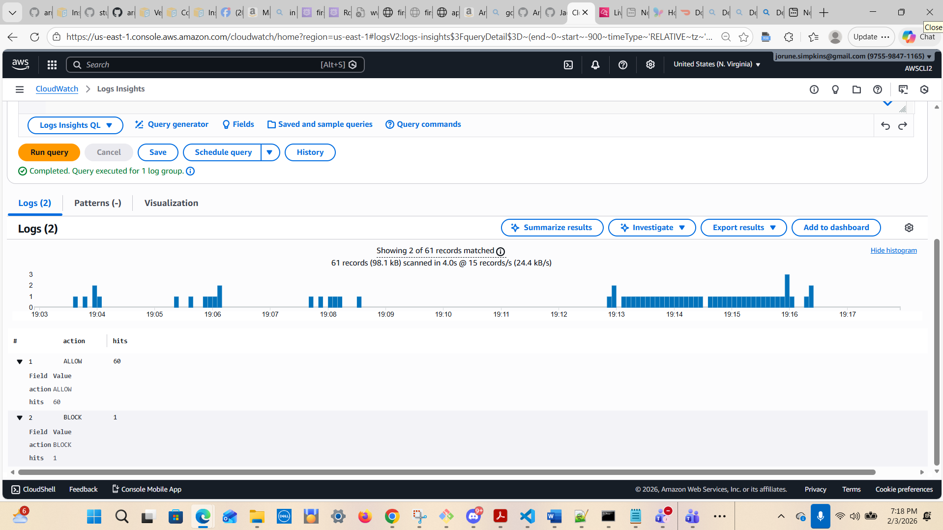

After running: app.firstpointand.click/.env
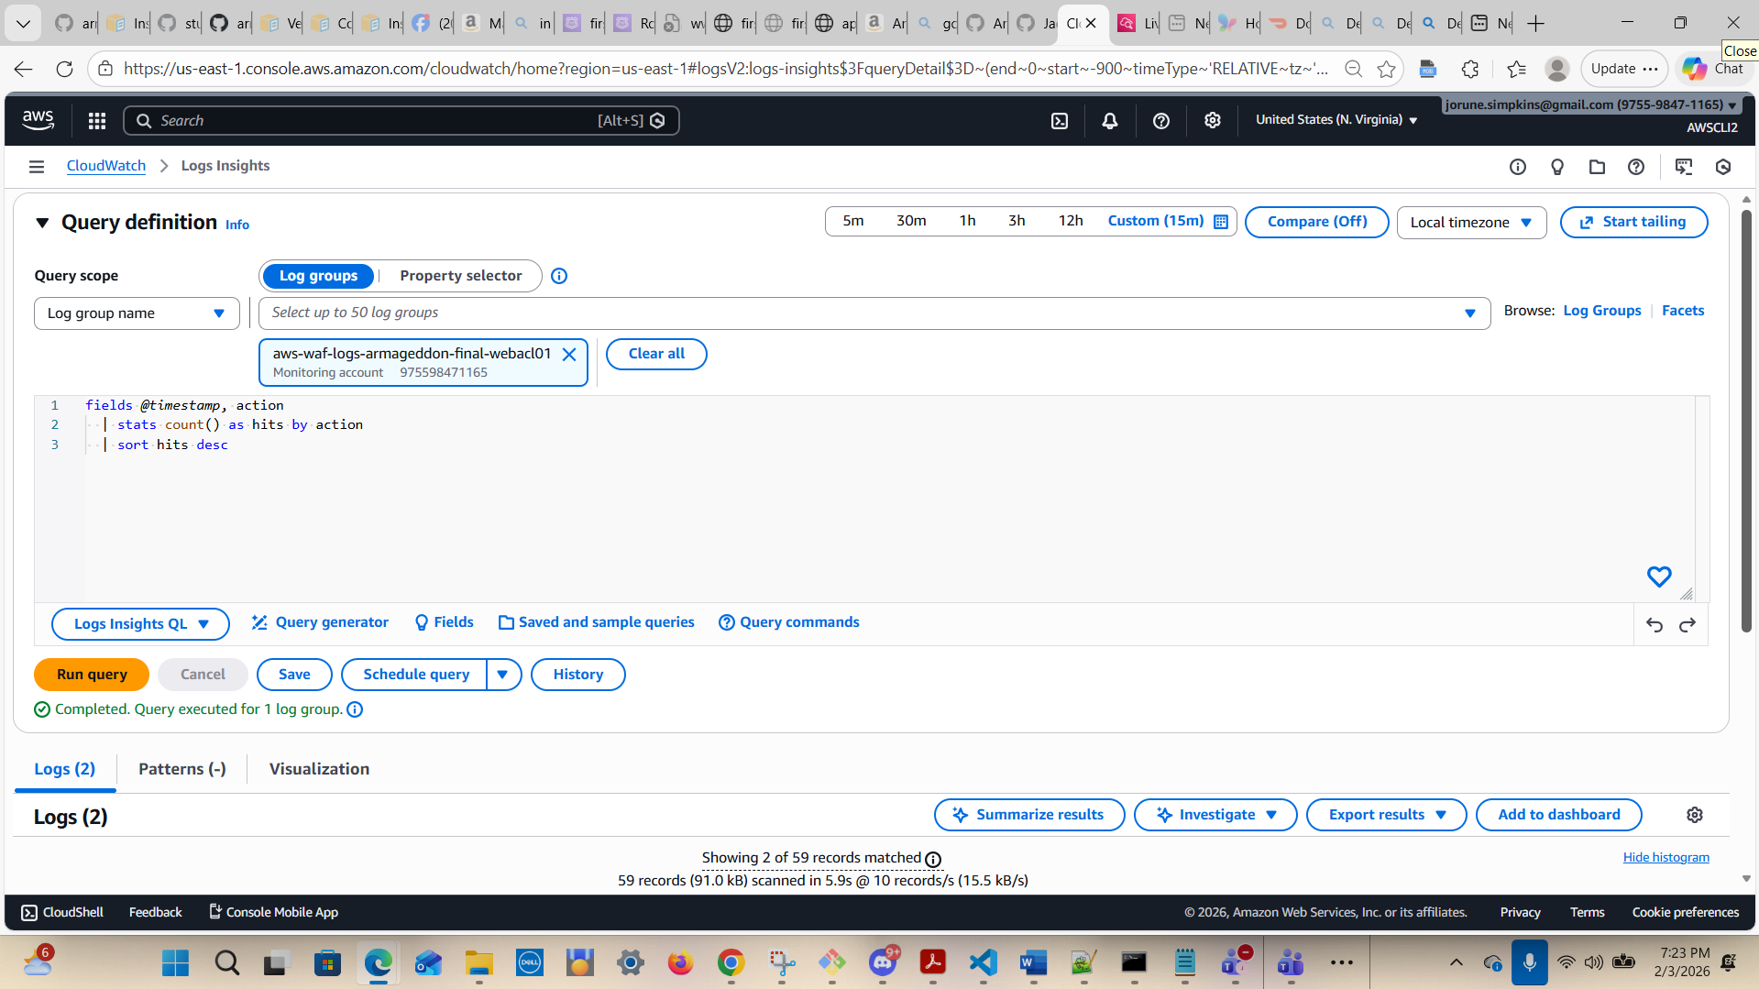
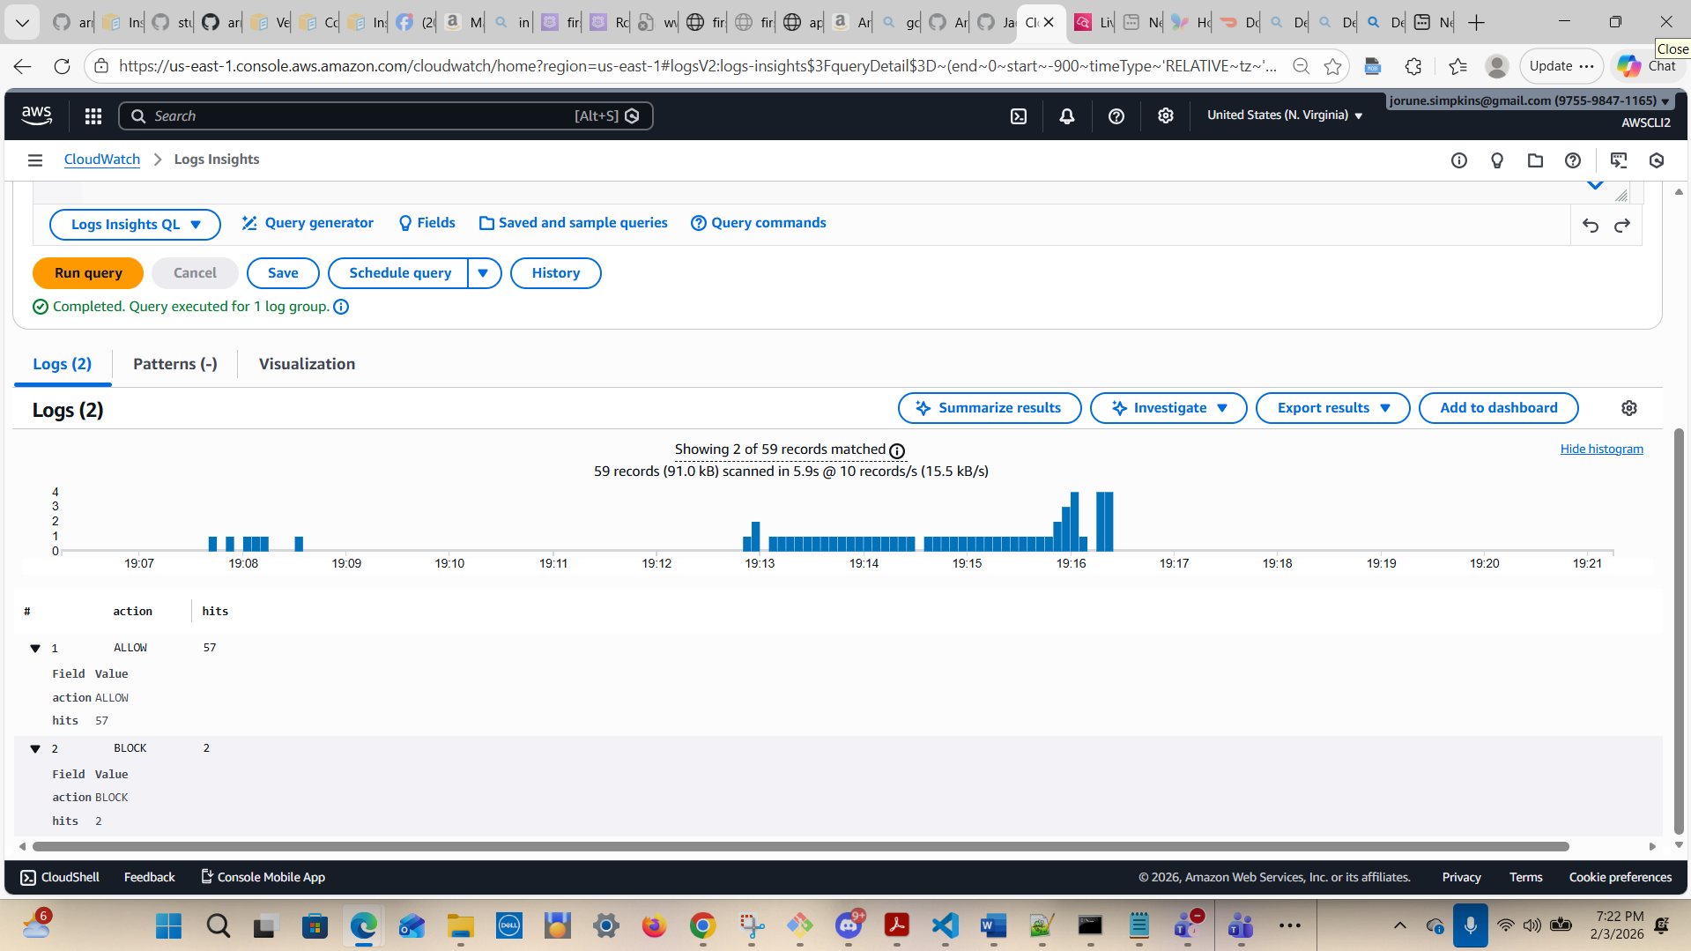

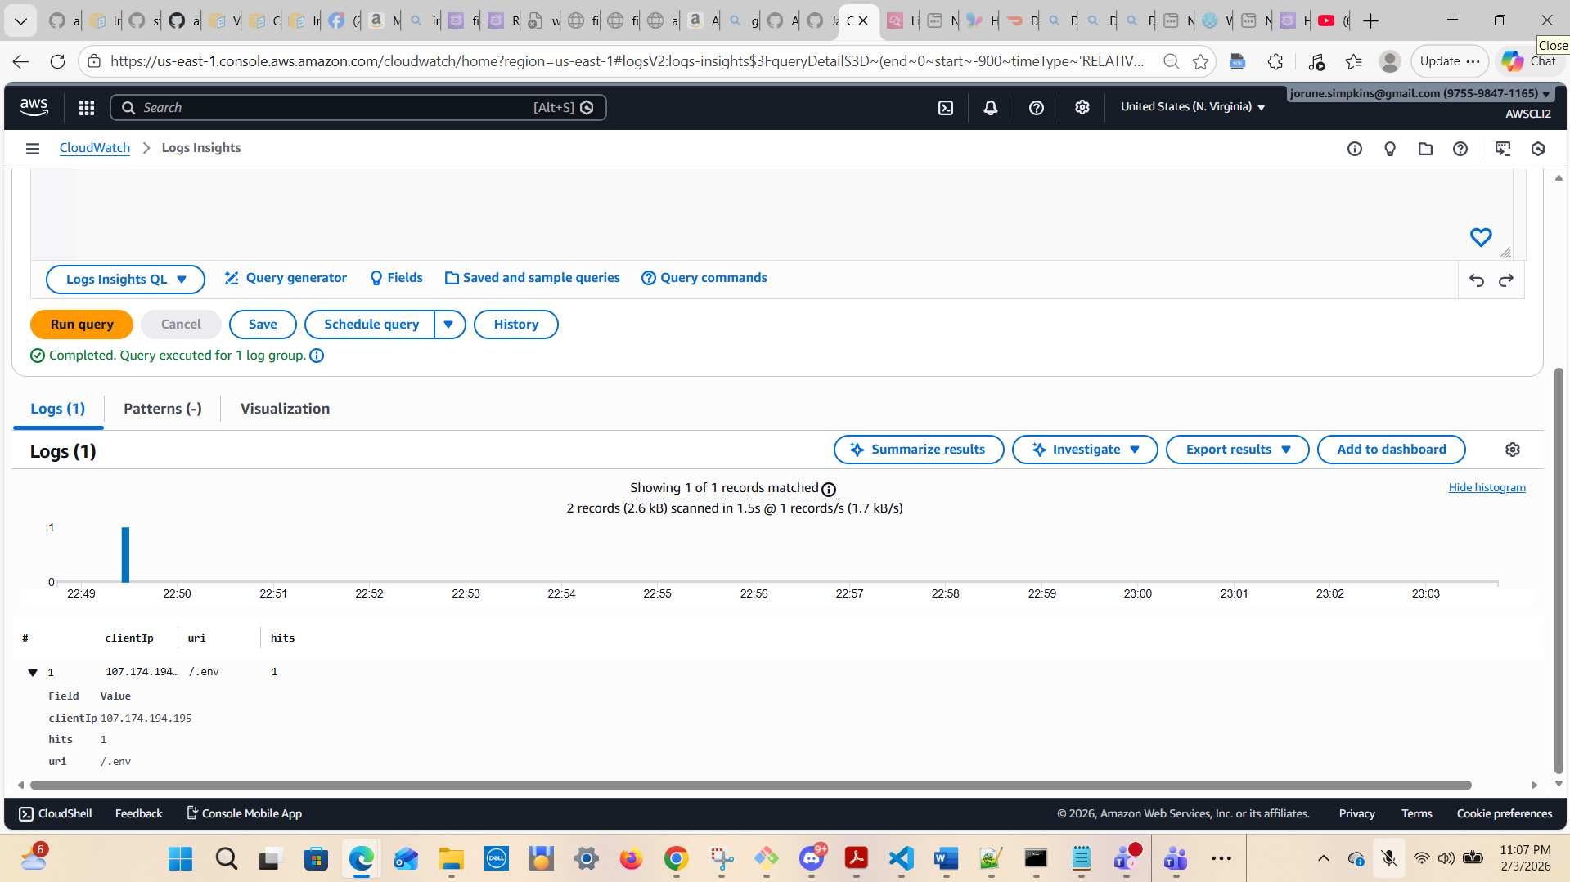

I included this screenshot for clarity
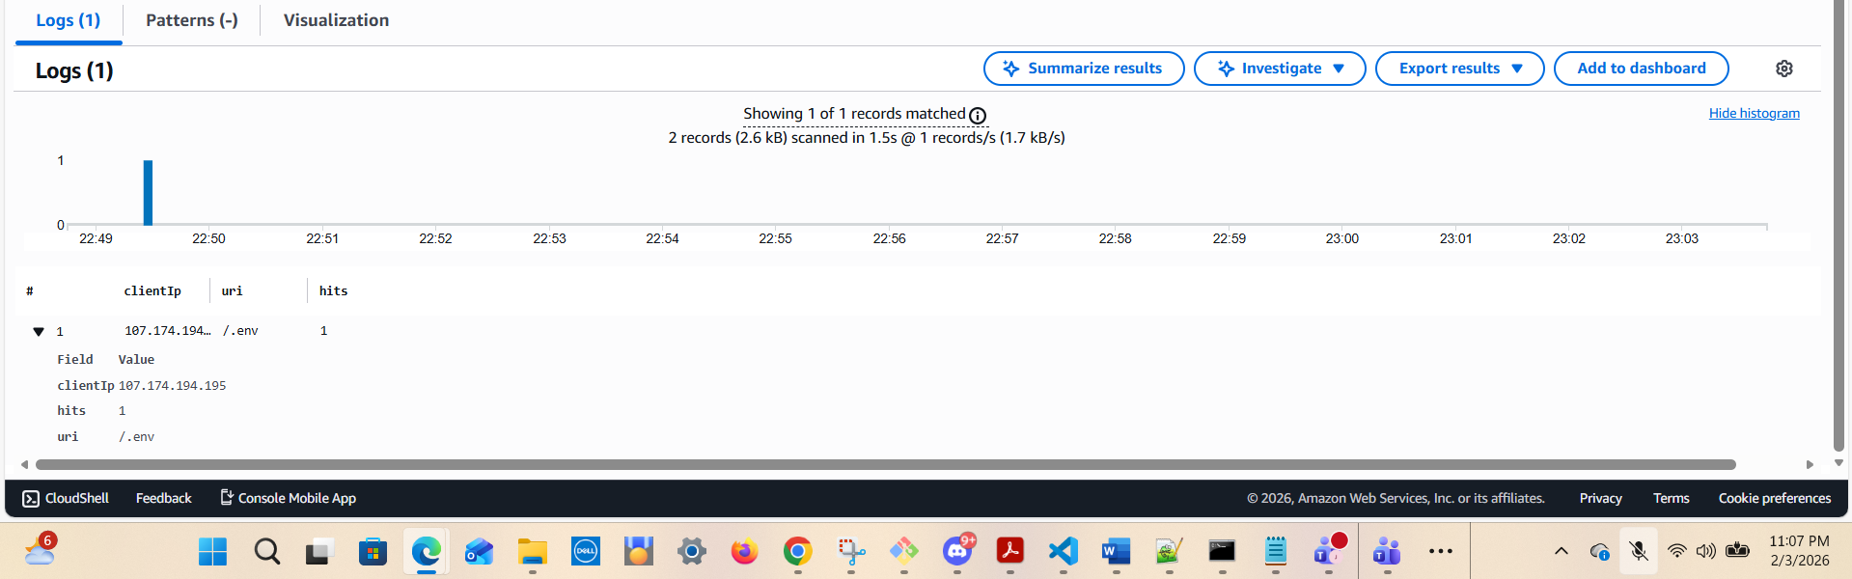

A7) Suspicious scanners (common patterns: admin paths, wp-login, etc.)
fields @timestamp, httpRequest.clientIp as clientIp, httpRequest.uri as uri
| filter uri like /wp-login|xmlrpc|\.env|admin|phpmyadmin|\.git|\/login/i
| stats count() as hits by clientIp, uri
| sort hits desc
| limit 50

A2) Top client IPs (who is hitting us the most?)
fields @timestamp, httpRequest.clientIp as clientIp
| stats count() as hits by clientIp
| sort hits desc
| limit 25
My IPv4 Address: 99.184.18.128
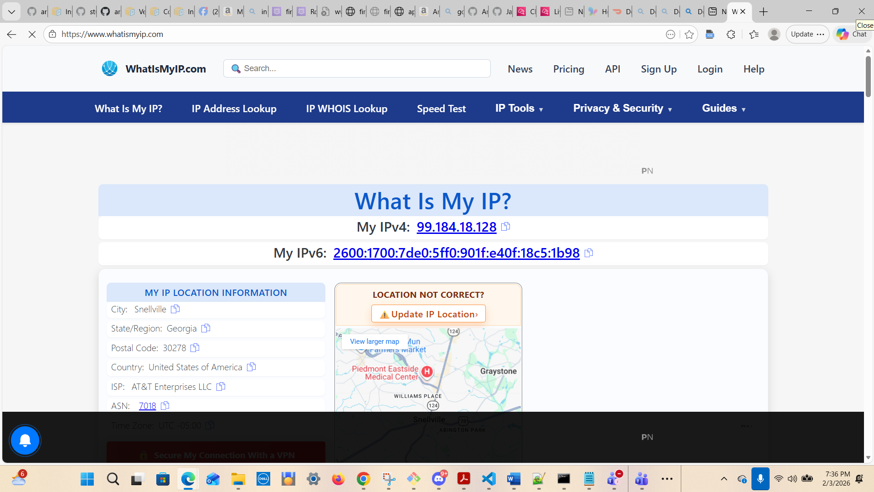

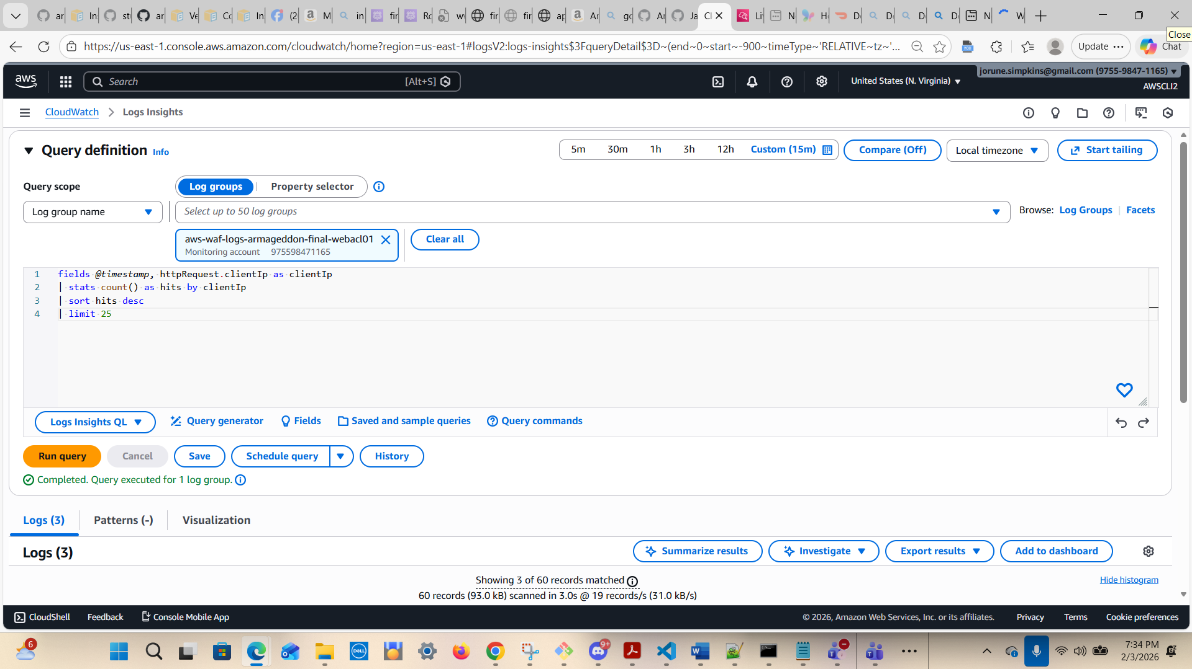

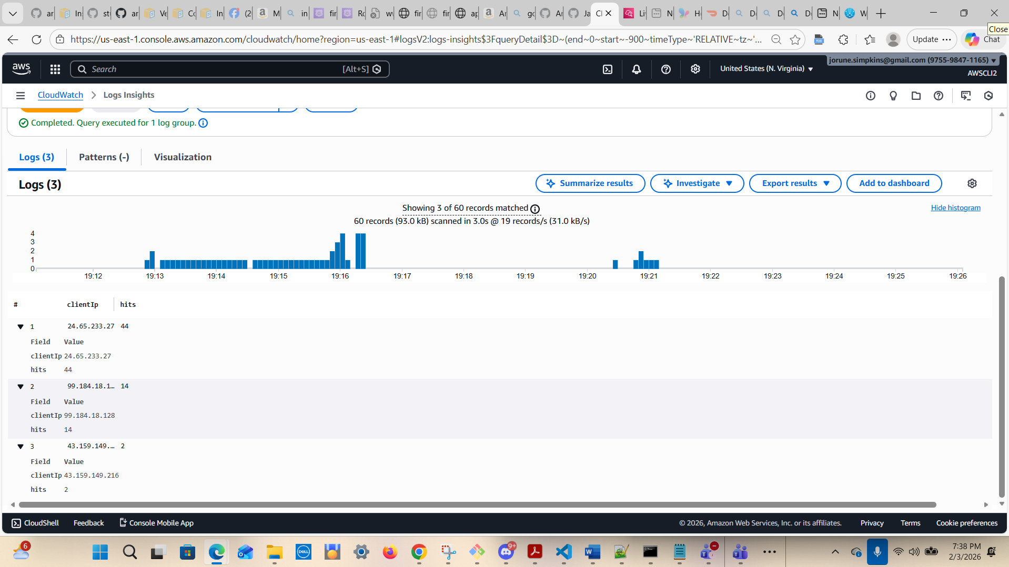

A3) Top requested URIs (what are they trying to reach?)
fields @timestamp, httpRequest.uri as uri
| stats count() as hits by uri
| sort hits desc
| limit 25

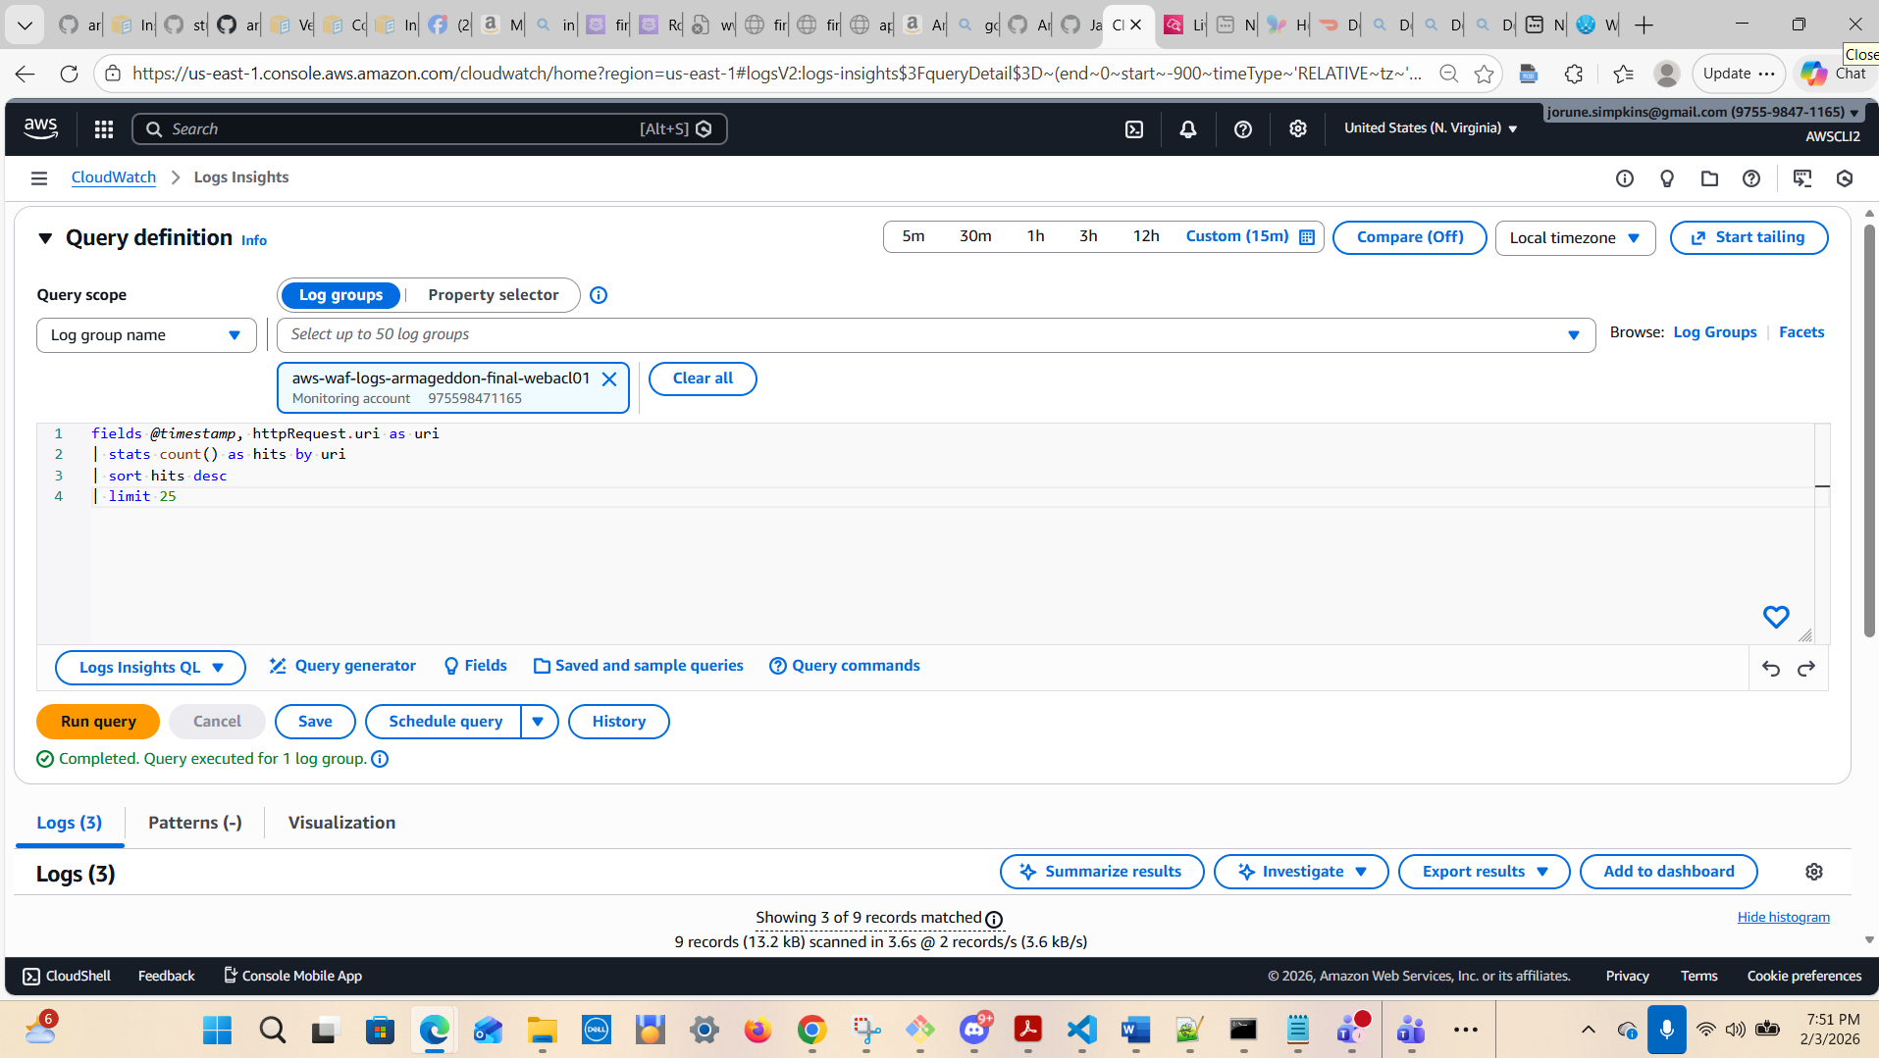

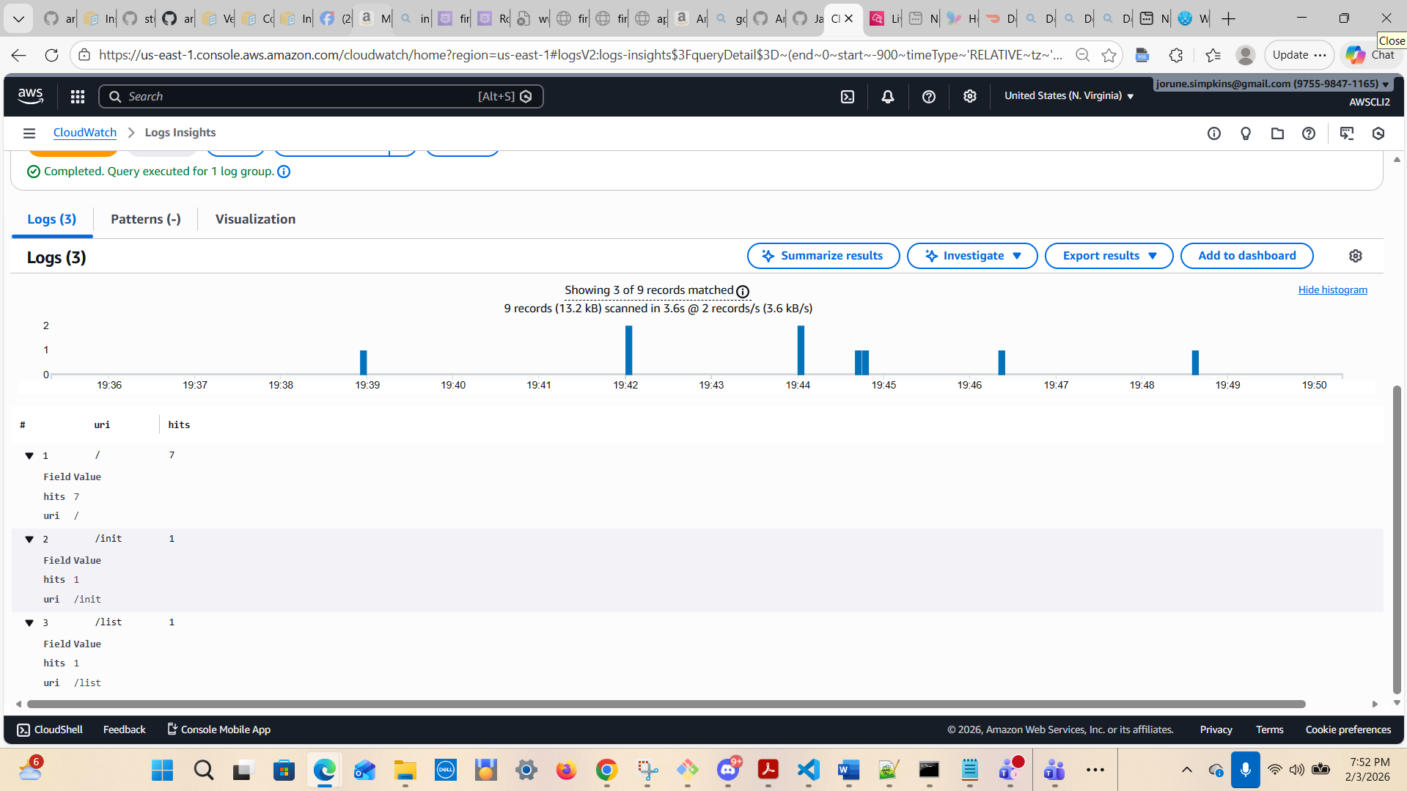

A4) Blocked requests only (who/what is being blocked?)
fields @timestamp, action, httpRequest.clientIp as clientIp, httpRequest.uri as uri
| filter action = "BLOCK"
| stats count() as blocks by clientIp, uri
| sort blocks desc
| limit 25
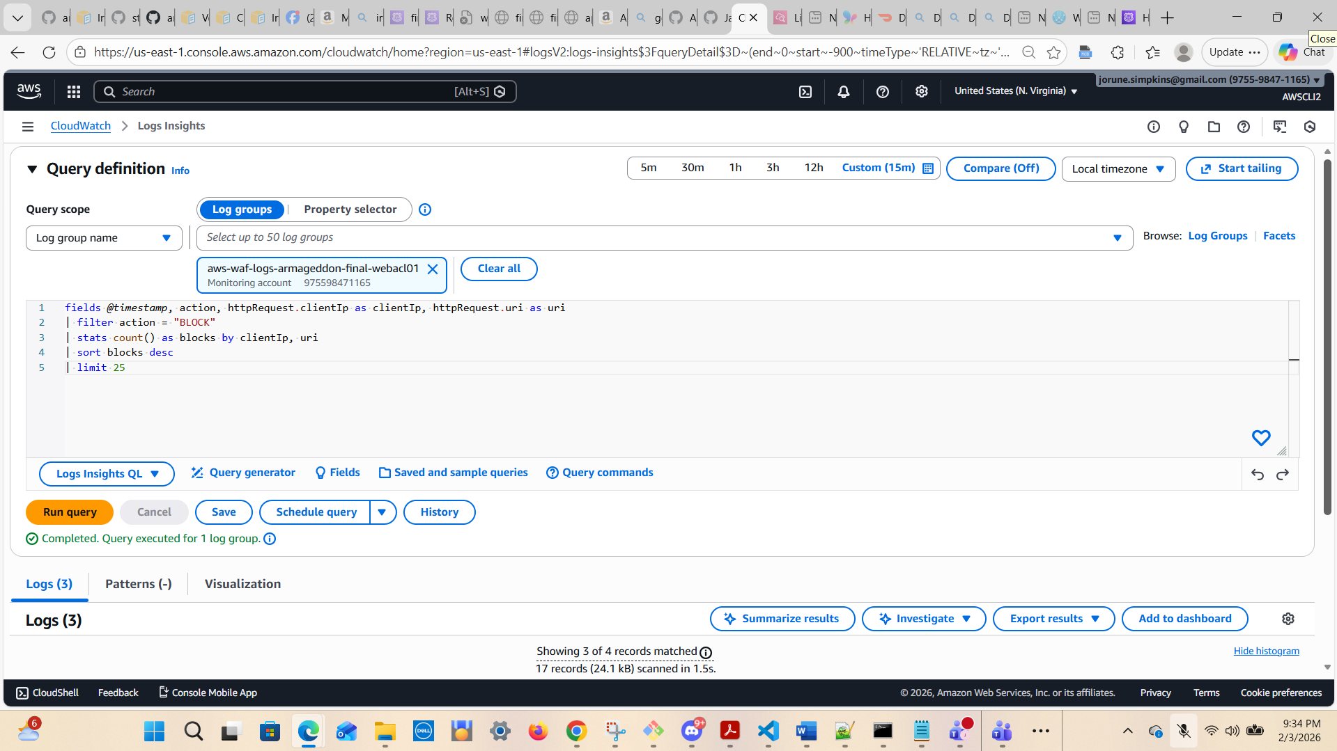

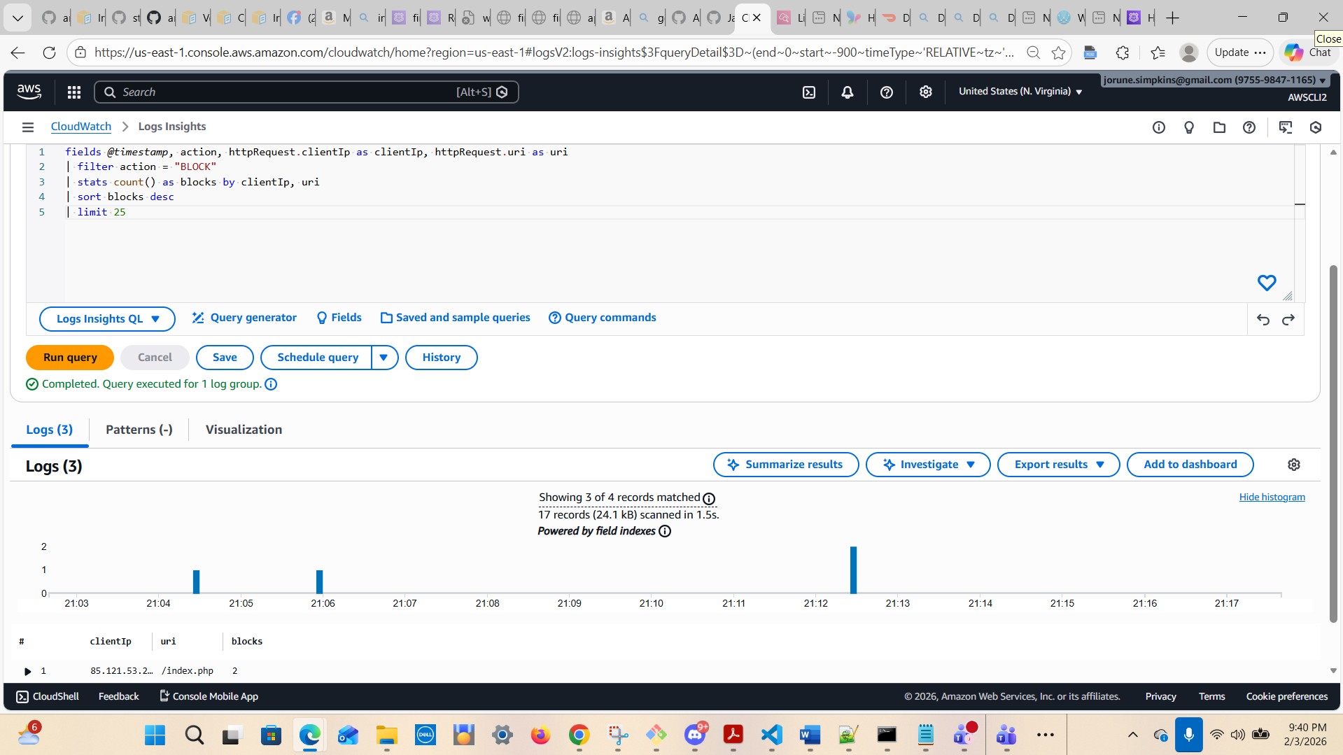

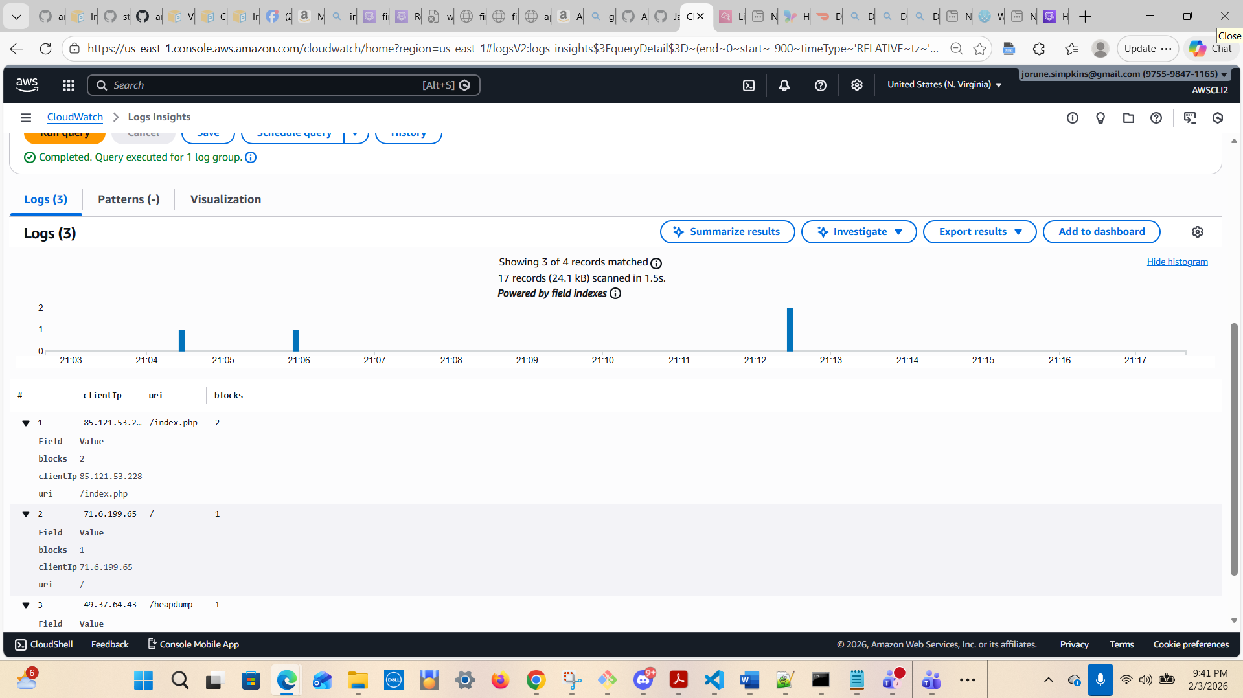

A5) Which WAF rule is doing the blocking?
fields @timestamp, action, terminatingRuleId, terminatingRuleType
| filter action = "BLOCK"
| stats count() as blocks by terminatingRuleId, terminatingRuleType
| sort blocks desc
| limit 25

Entered the list of items below to generate traffic and blocks:
BLOCKS:
https://app.firstpointand.click/.env
https://app.firstpointand.click/error
https://firstpointand.click/help
https://firstpointand.click/help

https://firstpointand.click/help
https://app.firstpointand.click/free
https://firstpointand.click/free
TRAFFIC:
https://app.firstpointand.click/add?text=LabEntry

https://app.firstpointand.click/list
https://firstpointand.click/
https://firstpointand.click/

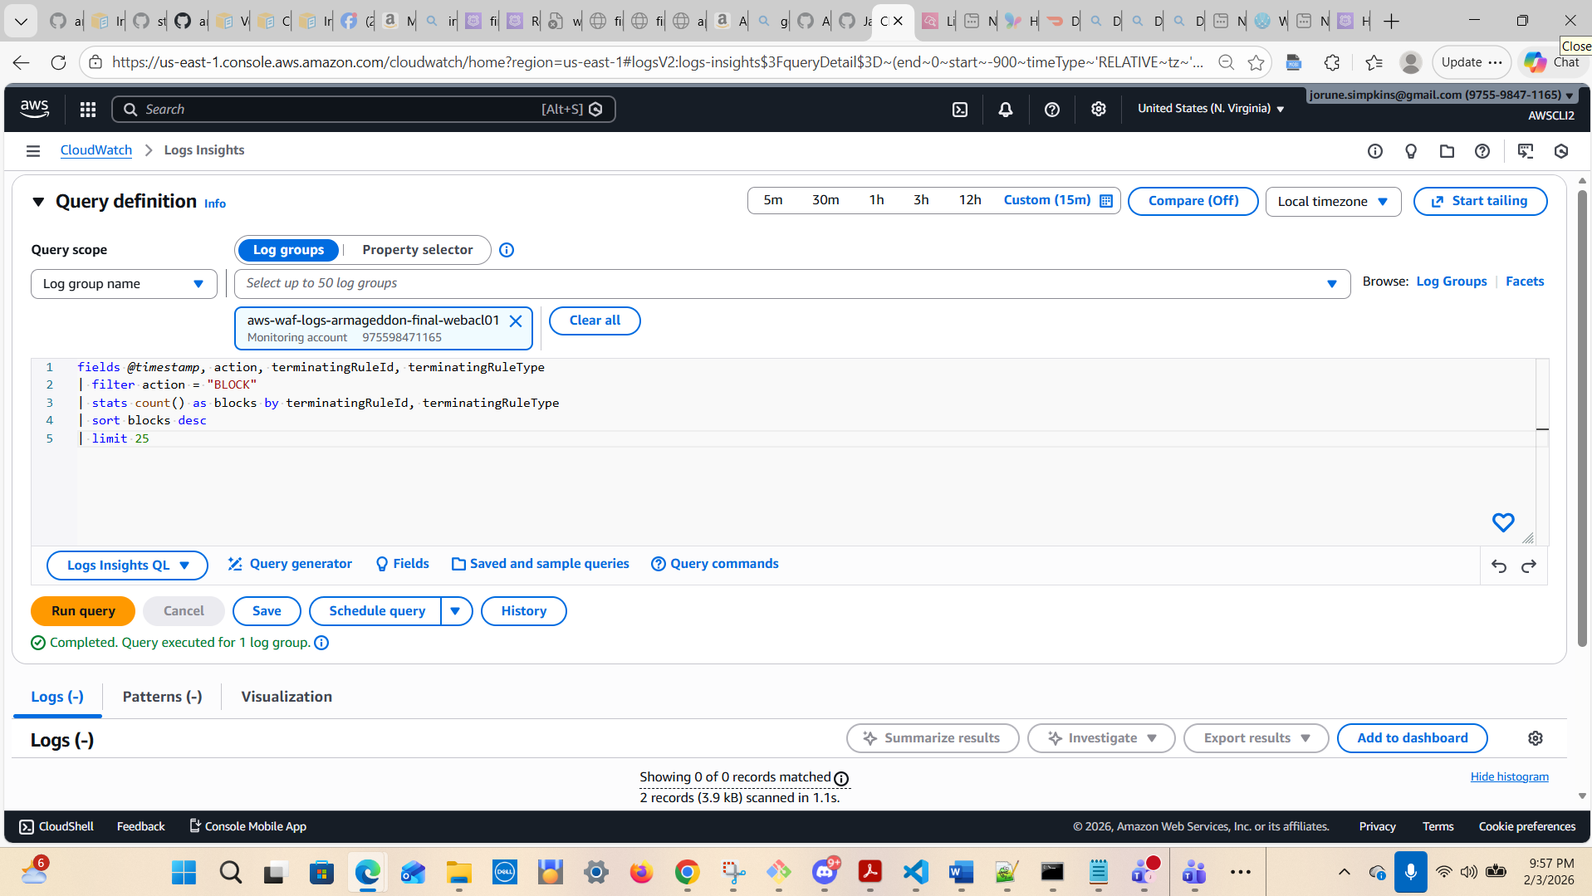

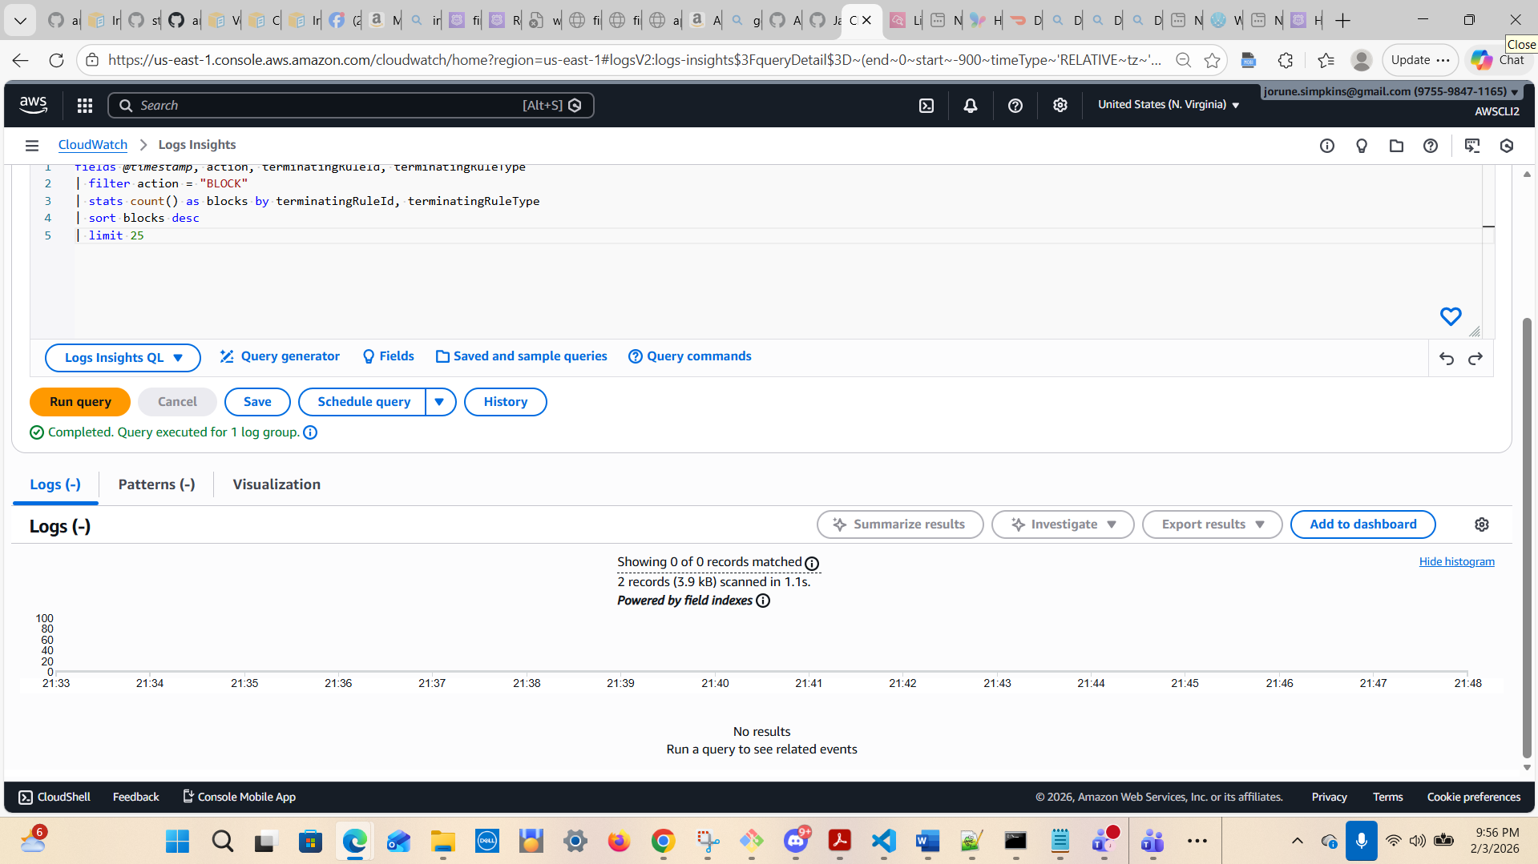


A6) Rate of blocks over time (did it spike?)
fields @timestamp, httpRequest.clientIp as clientIp, httpRequest.uri as uri
| filter uri like /wp-login|xmlrpc|\.env|admin|phpmyadmin|\.git|\/login/i
| stats count() as hits by clientIp, uri
| sort hits desc
| limit 50

NOTE: I ran the edited version below:
fields @timestamp, httpRequest.clientIp as clientIp, httpRequest.uri as uri | filter uri =~ /wp-login|xmlrpc|\.env|admin|phpmyadmin|\.git|login/ | stats count() as hits by clientIp, uri | sort hits desc | limit 50

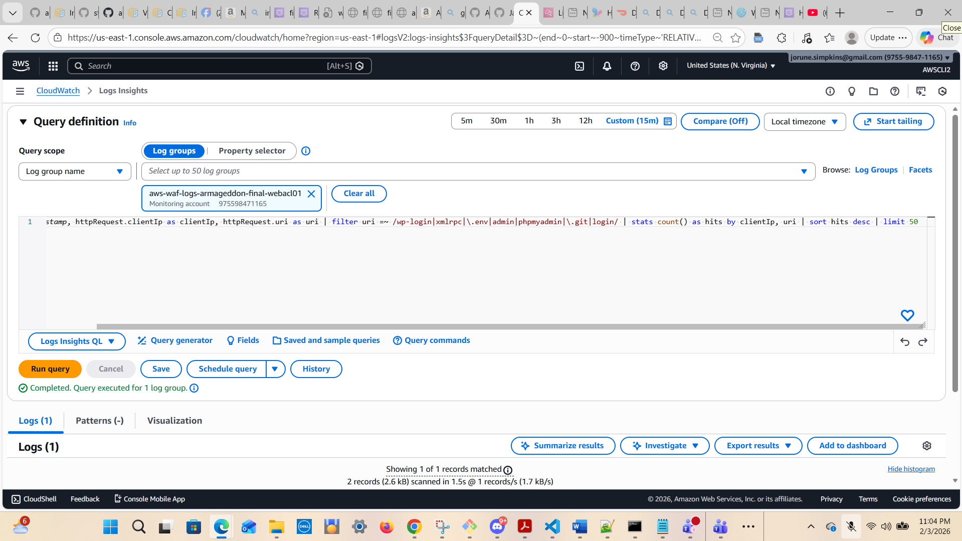

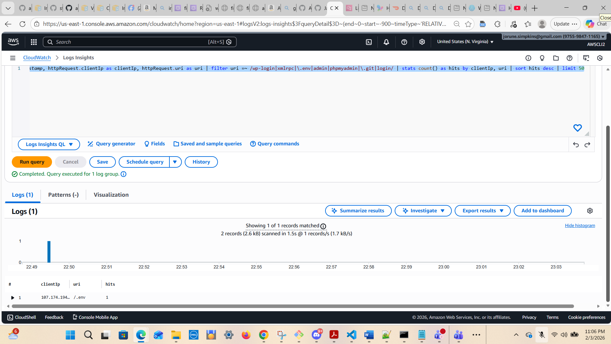

A7) Suspicious scanners (common patterns: admin paths, wp-login, etc.)
fields @timestamp, httpRequest.clientIp as clientIp, httpRequest.uri as uri
| filter uri like /wp-login|xmlrpc|\.env|admin|phpmyadmin|\.git|login/
| stats count() as hits by clientIp, uri
| sort hits desc
| limit 50

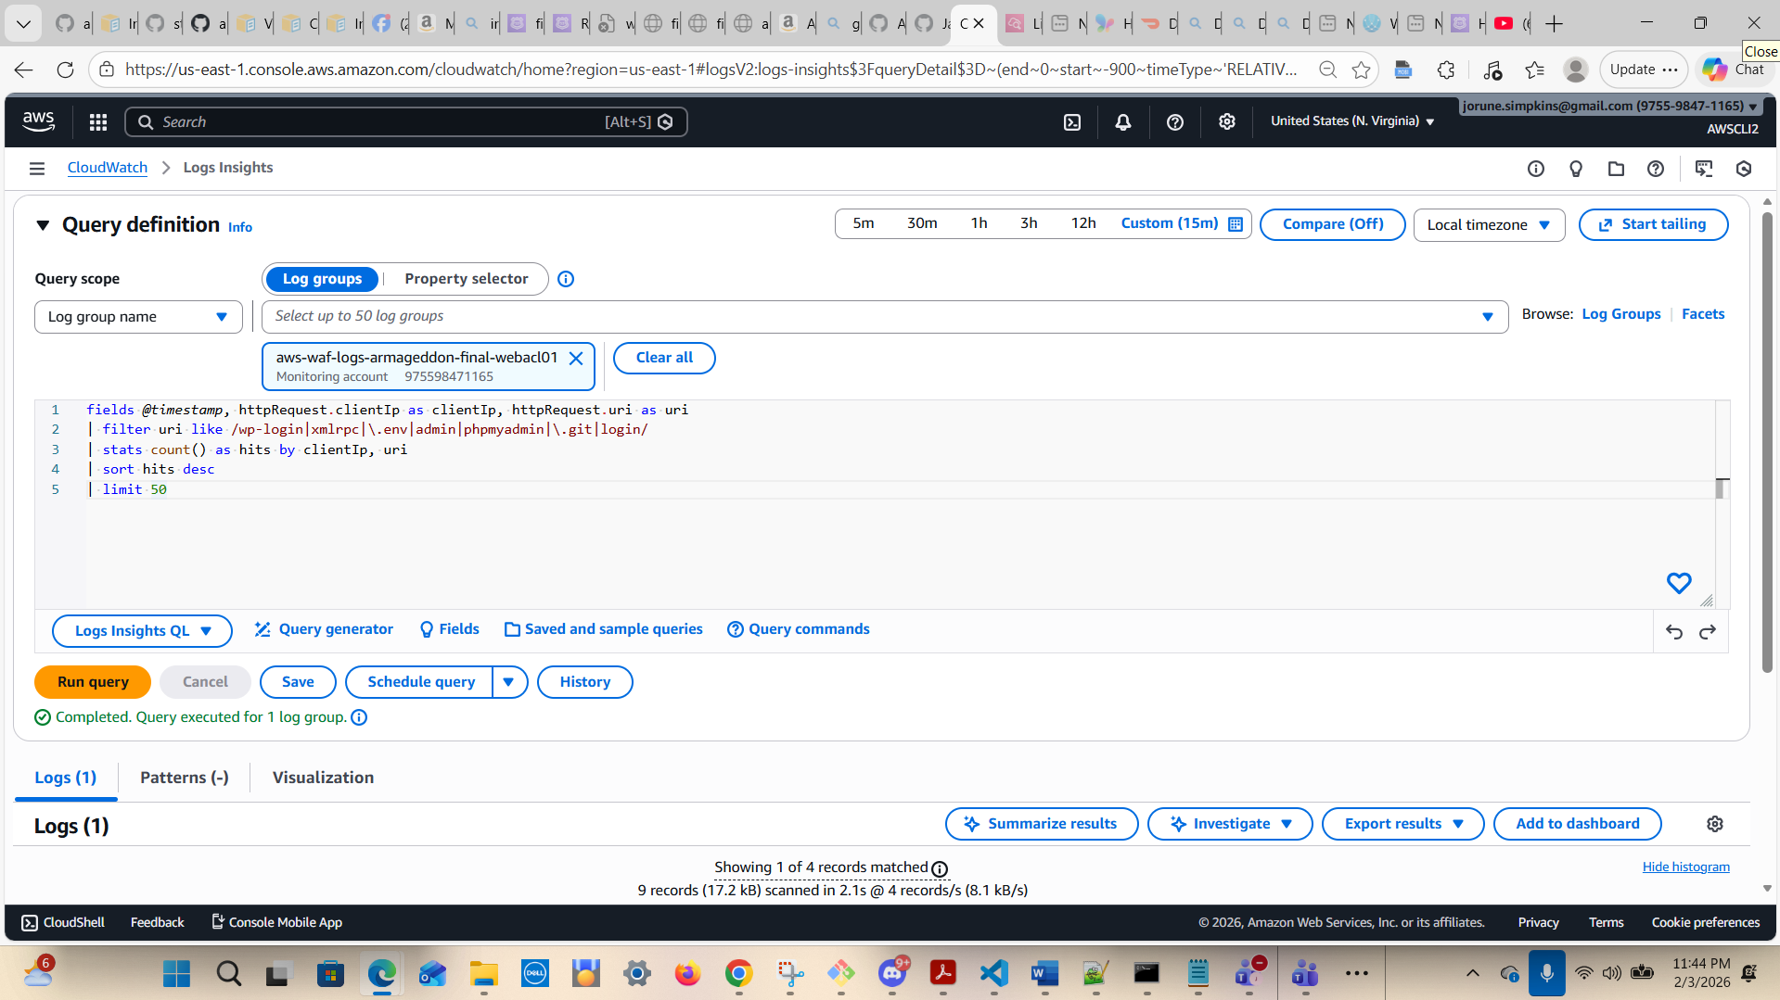

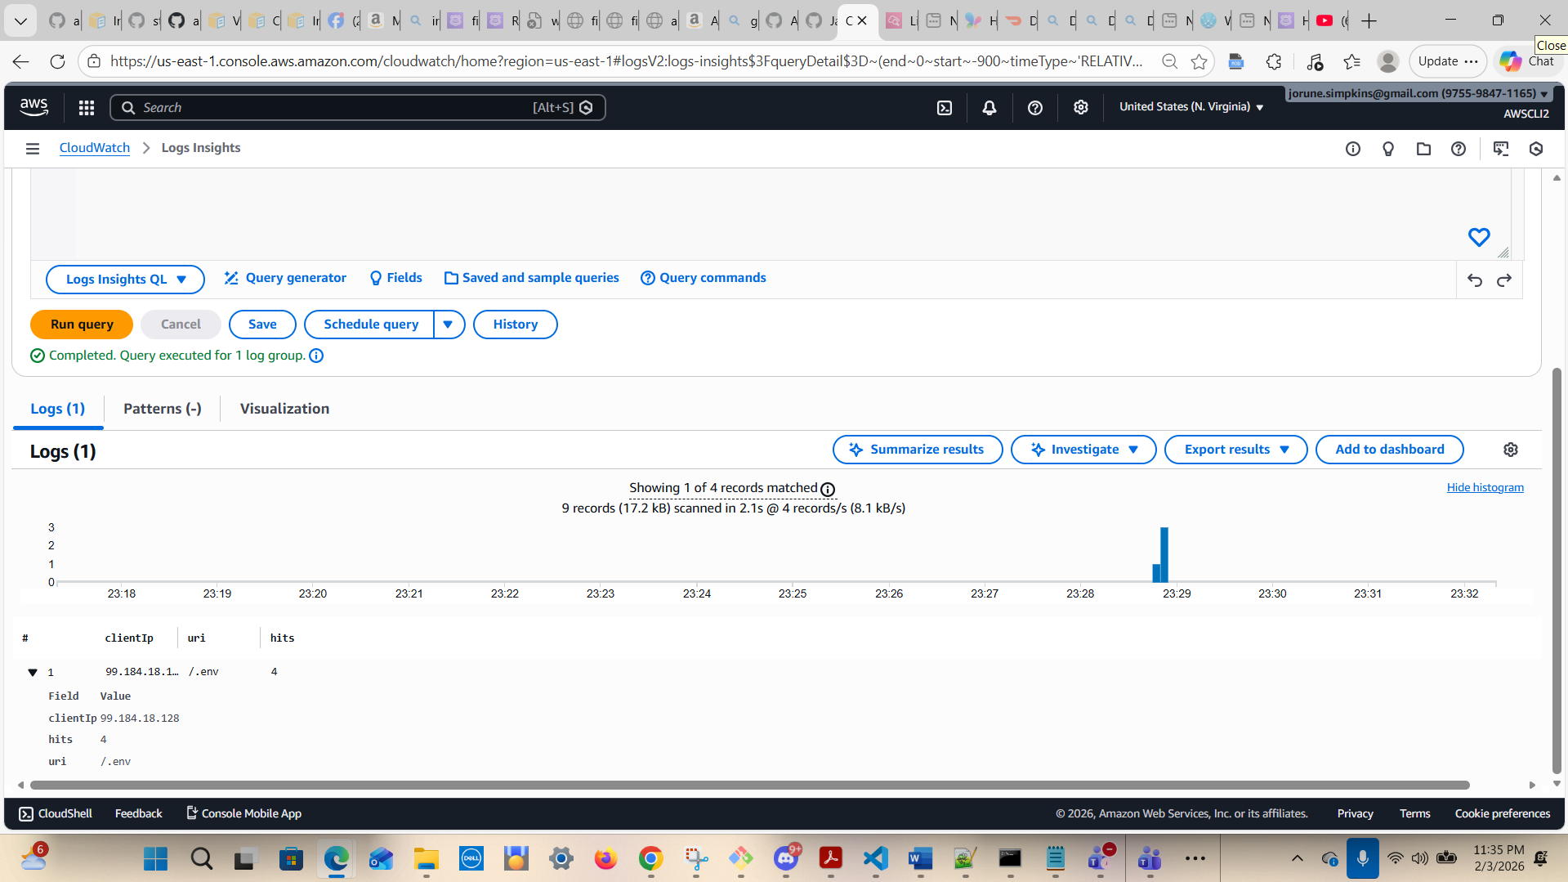

A8) Country/geo (if present in your WAF logs)
Some WAF log formats include httpRequest.country. If yours does:
fields @timestamp, httpRequest.country as country
| stats count() as hits by country
| sort hits desc
| limit 25
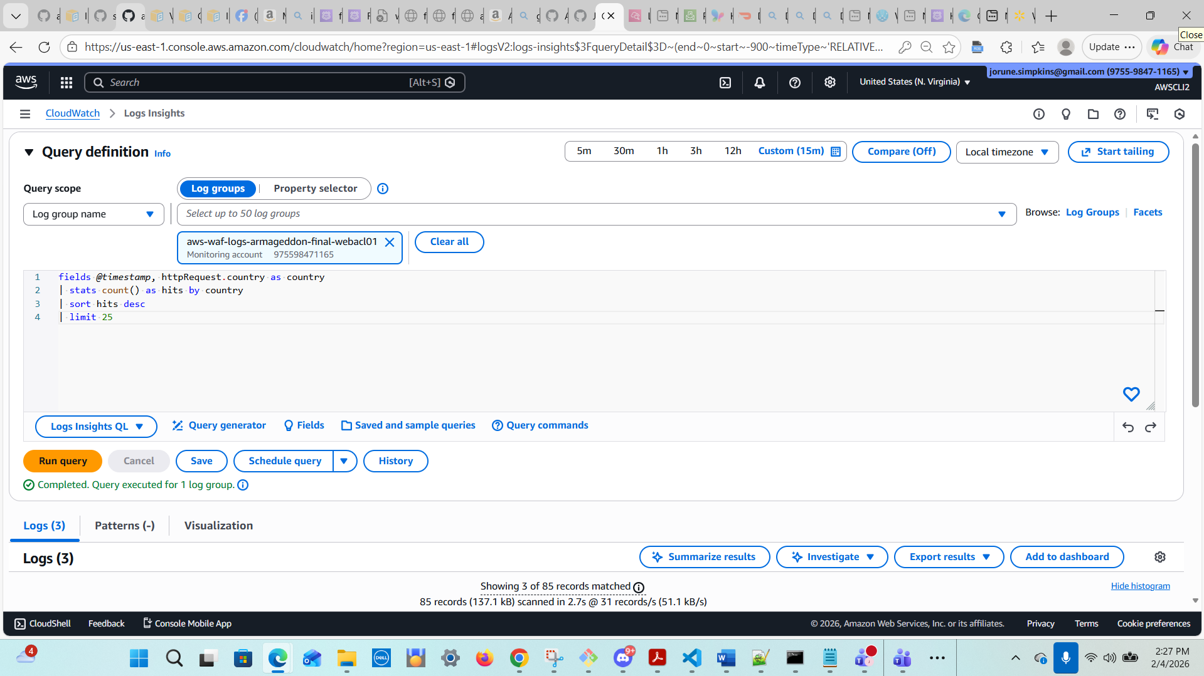

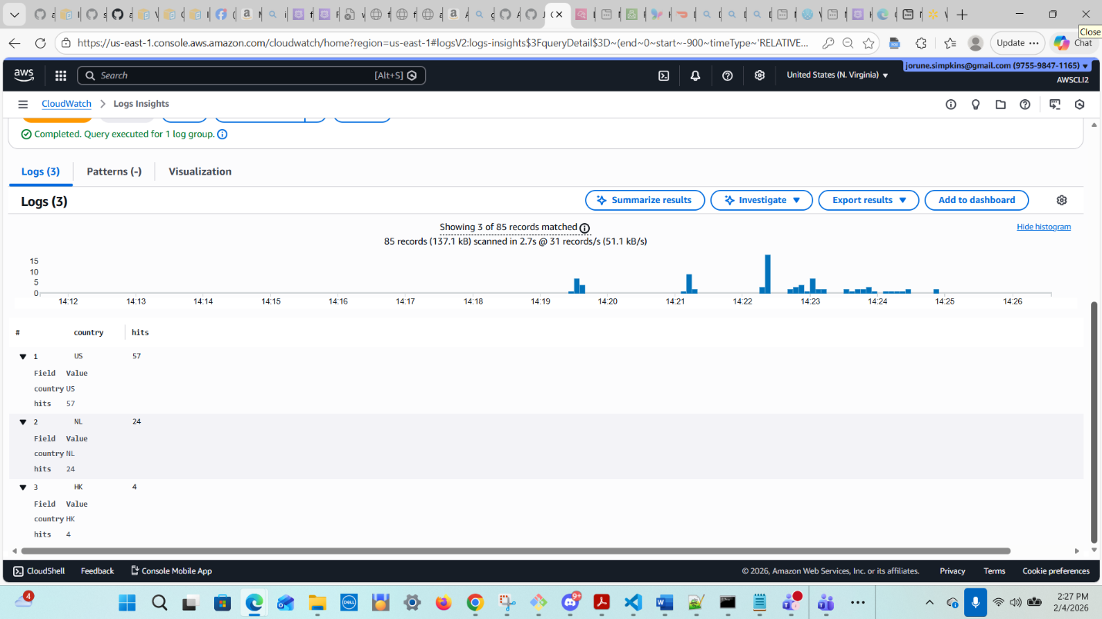
B1) Count errors over time (this should line up with the alarm window)
fields @timestamp, @message
| filter @message like /ERROR|Exception|Traceback|DB|timeout|refused/i
| stats count() as errors by bin(1m)
| sort bin(1m) asc

NOTE: *****The code has to be corrected to the following:
fields @timestamp, @message
| filter @message like /(?i)ERROR|Exception|Traceback|DB|timeout|refused/
| stats count(*) as errors by bin(1m)
| sort errors desc

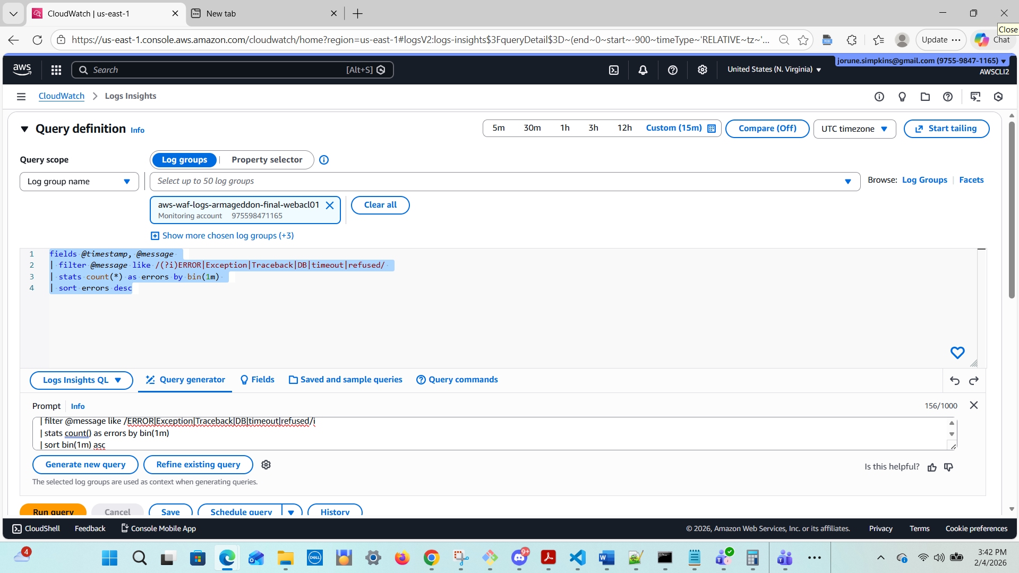

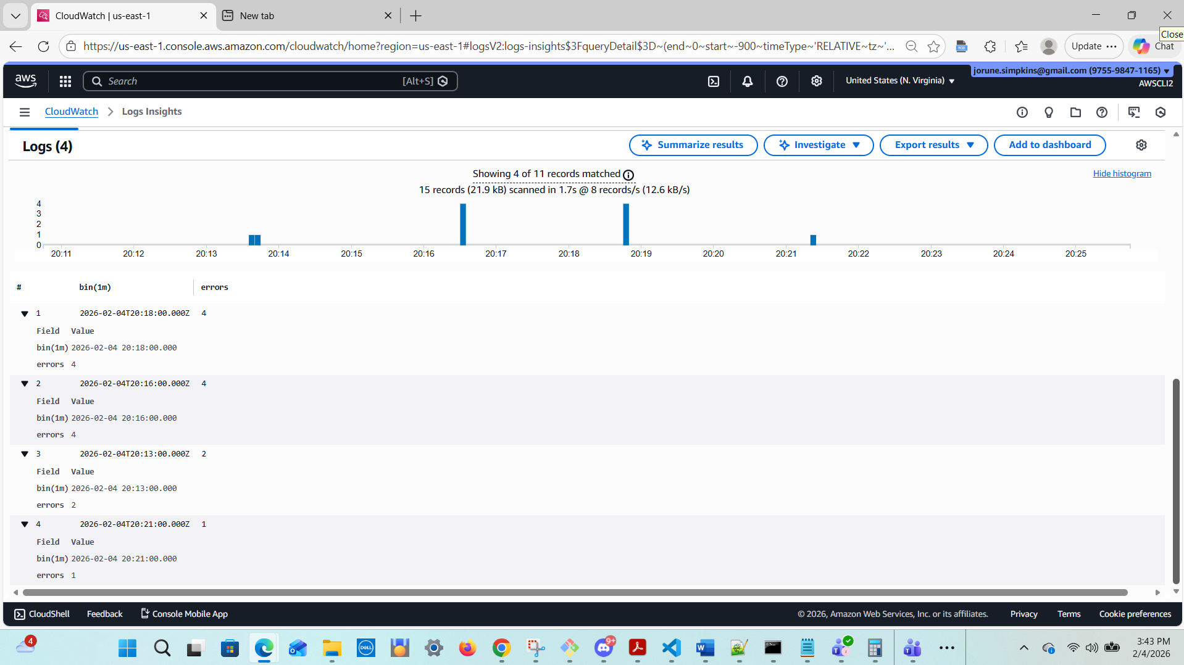

B2) Show the most recent DB failures (triage view)
fields @timestamp, @message
| filter @message like /DB|mysql|timeout|refused|Access denied|could not connect/i
| sort @timestamp desc
| limit 50

Corrected Query:
fields @timestamp, @message
| filter @message like /(?i)DB|mysql|timeout|refused|Access denied|could not connect/
| sort @timestamp desc
| limit 50
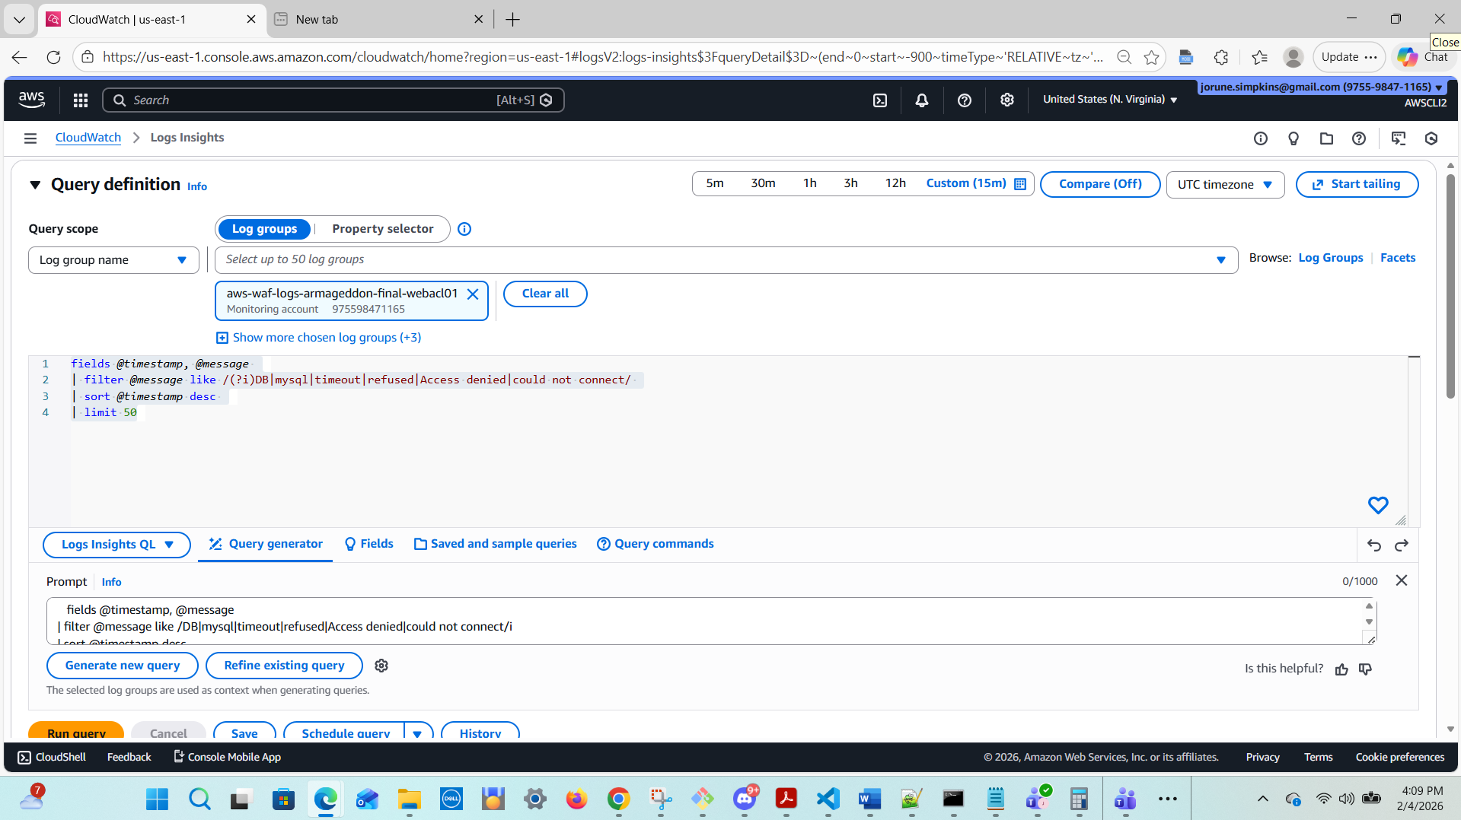
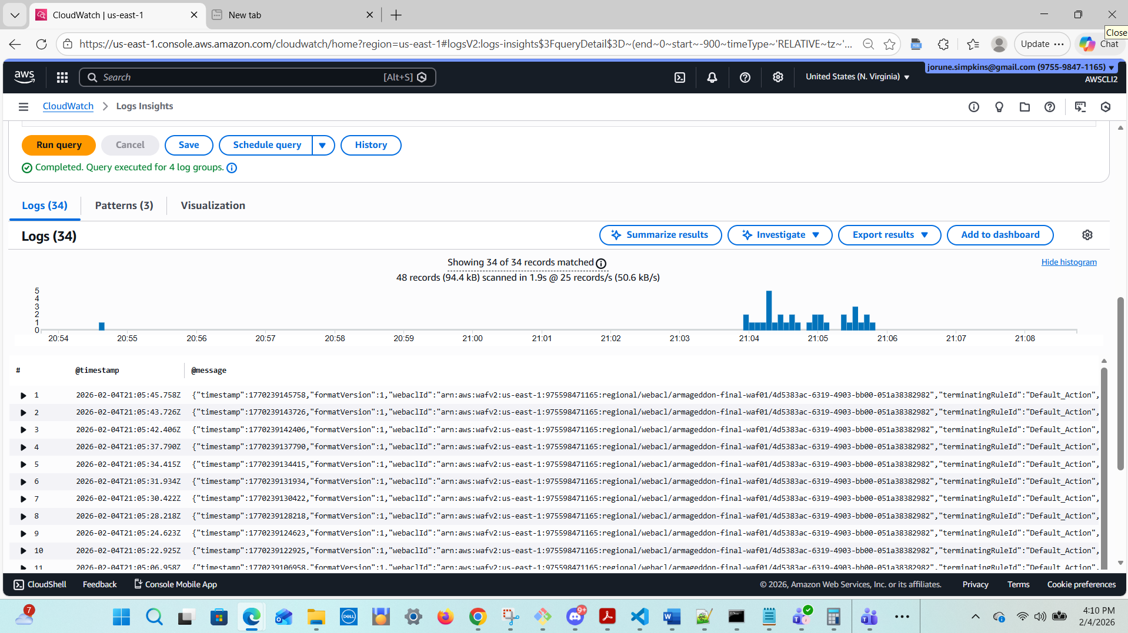
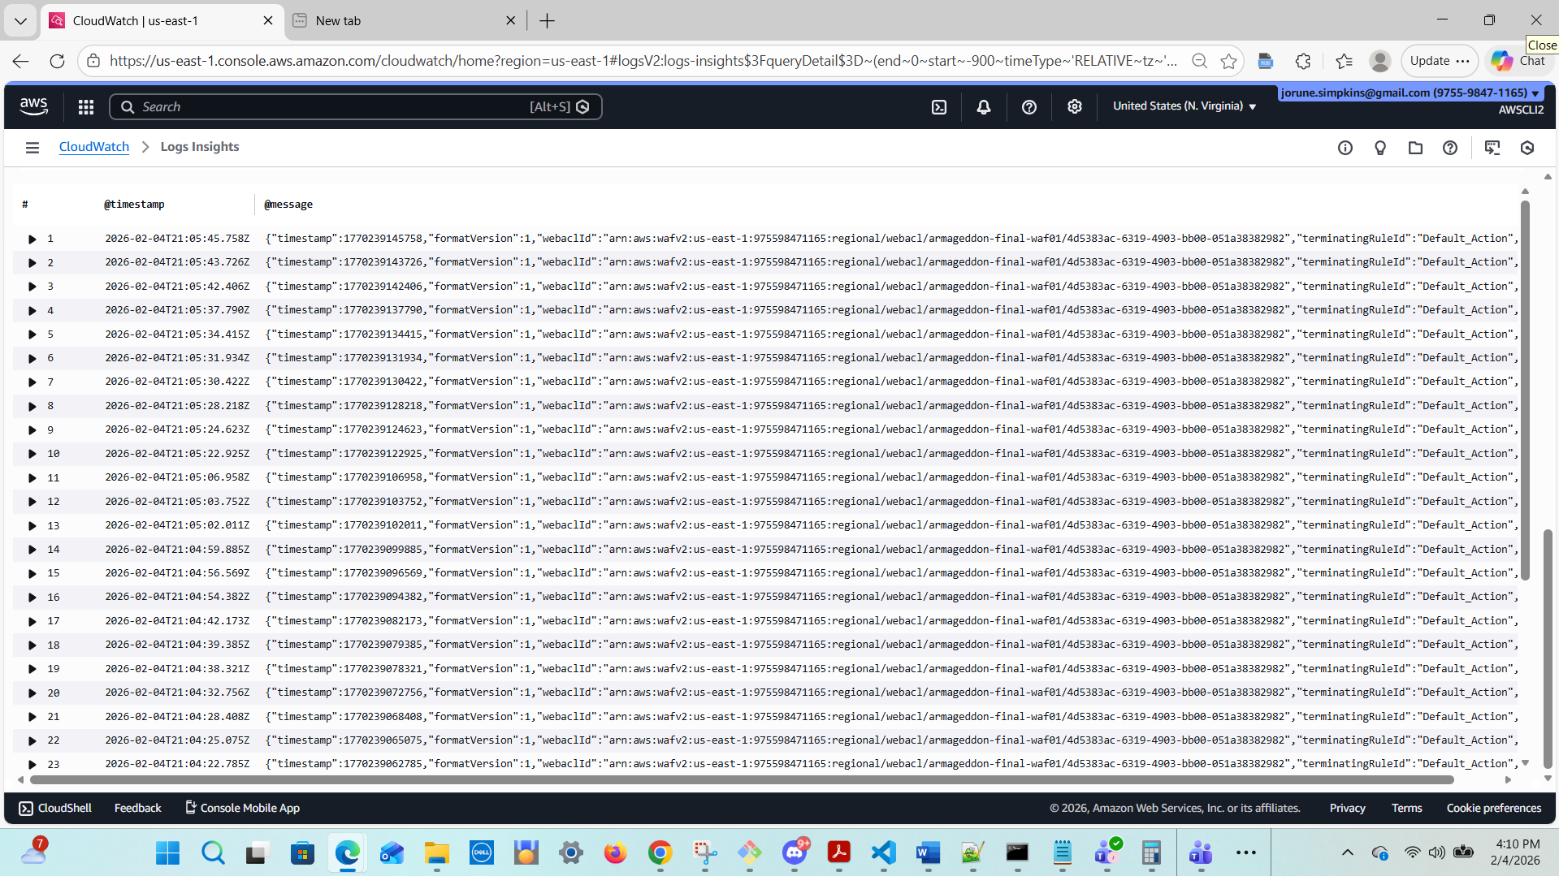
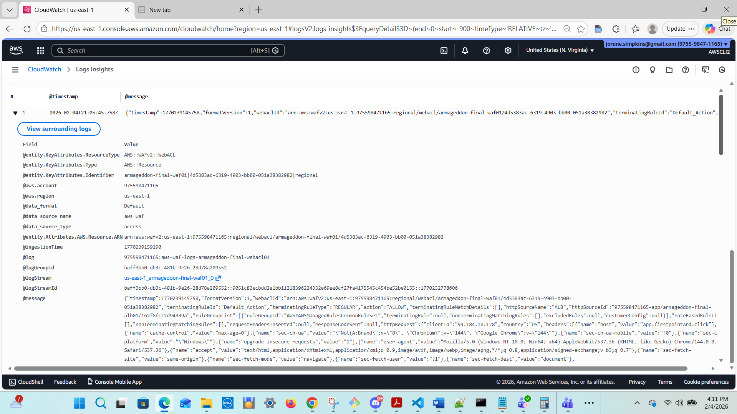
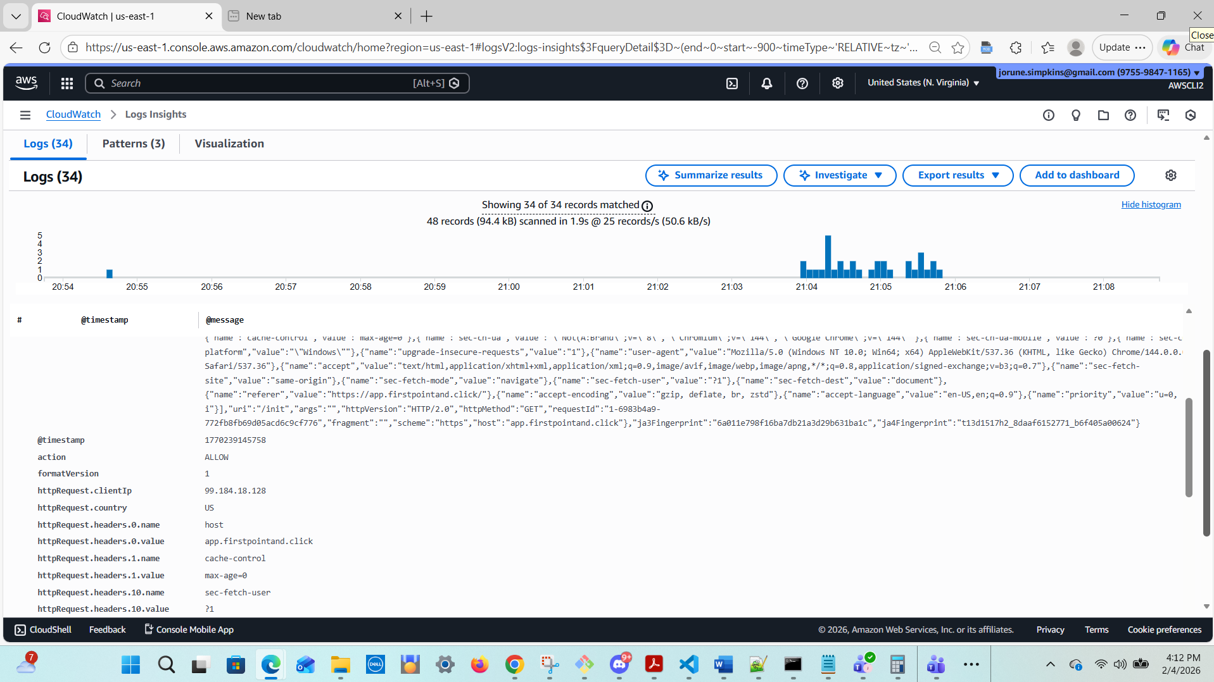
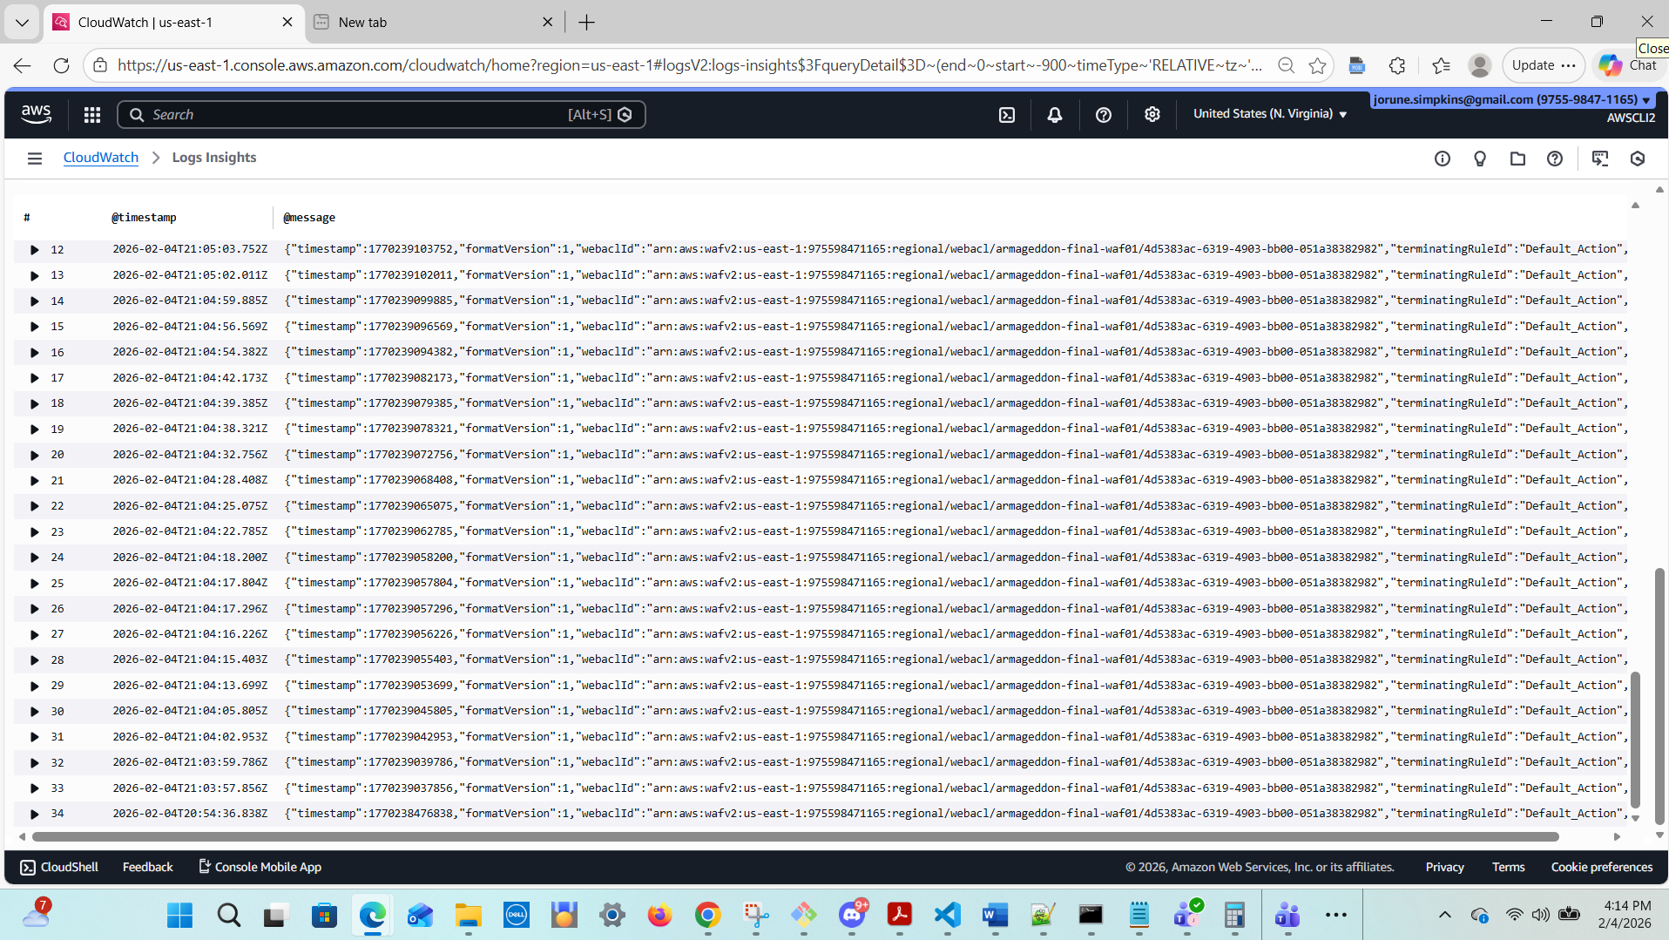

B3) “Is it creds or network?” classifier hints
Credentials drift often shows: Access denied, authentication failures
Network/SecurityGroup often shows: timeout, refused, “no route”, hang
fields @timestamp, @message
| filter @message like /Access denied|authentication failed|timeout|refused|no route|could not connect/i
| stats count() as hits by
case(
@message like /Access denied|authentication failed/i, "Creds/Auth",
@message like /timeout|no route/i, "Network/Route",
@message like /refused/i, "Port/SG/ServiceRefused",
"Other"
)
| sort hits des

fields @timestamp, @message
| filter @message like /Access denied|authentication failed|timeout|refused|no route|could not connect/i
| stats count() as hits by
case(
@message like /Access denied|authentication failed/i, "Creds/Auth",
@message like /timeout|no route/i, "Network/Route",
@message like /refused/i, "Port/SG/ServiceRefused",
"Other"
)
| sort hits desc

Updated:
fields @timestamp, @message
| filter @message like /(?i)Access denied|authentication failed|timeout|refused|no route|could not connect/
| stats count() as hits by bin(5m)
| sort hits desc

B4) Extract structured fields (Requires log JSON)
If you log JSON like: {"level":"ERROR","event":"db_connect_fail","reason":"timeout"}:
fields @timestamp, level, event, reason
| filter level="ERROR"
| stats count() as n by event, reason
| sort n desc

(Thou Shalt need to emit JSON logs for this one.)

C) Correlation “Enterprise-style” mini-workflow (Runbook Section)
Add this to the incident runbook:

Step 1 — Confirm signal timing
CloudWatch alarm time window: last 5–15 minutes
Run App B1 to see error spike time bins

Step 2 — Decide: Attack vs Backend Failure
Run WAF A1 + A6:
If BLOCK spikes align with incident time → likely external pressure/scanning
If WAF is quiet but app errors spike → likely backend (RDS/SG/creds)

Step 3 — If backend failure suspected
Run App B2 and classify:
Access denied → secrets drift / wrong password
timeout → SG/routing/RDS down
Then retrieve known-good values:
Parameter Store /lab/db/*
Secrets Manager /<prefix>/rds/mysql

Step 4 — Verify recovery
App errors return to baseline (B1)
WAF blocks stabilize (A6)
Alarm returns to OK
curl https://app.chewbacca-growl.com/list works

